The Global Public-Private Partnership (G3P)

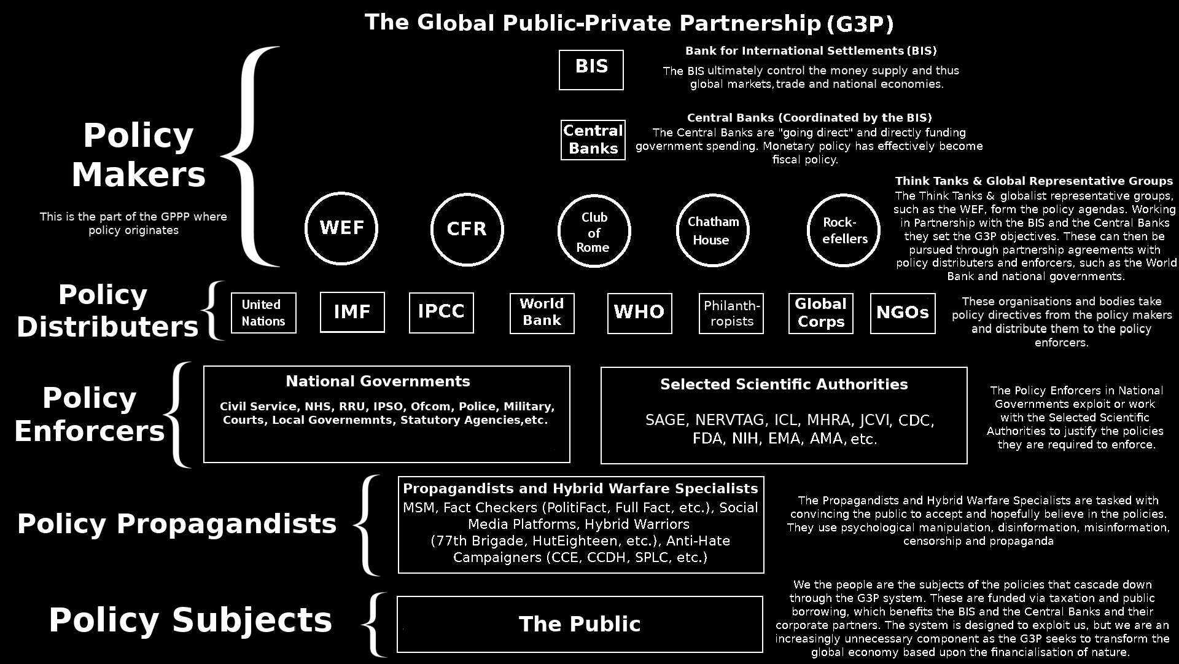

# Policy Makers

## BIS

## Central Banks

## WEF

## CFR

## Club of Rome

## Chatham House Rockefellers

# Policy Distributers

## United Nations

## IMF

## IPCC

## World Bank

## WHO

## Philanthropists

## Global Corps NGOs

# Policy Enforcers

## National Governments

Civil Service, NHS, RRU, IPSO, Ofcom, Police, Military, Courts, Local Governments, Statutory Agencies, etc.

## Selected Scientific Authorities

SAGE, NERVTAG, ICL, MHRA, JVCI, CDC, FDA, NIH, EMA, AMA, etc.

# Policy Propagandists

Propagandists and Hybrid Warfare Specialists

MSM, Fact Checkers, Social Media Patforms, Hybrid Warriors (77th Brigade, HutEighteen, etc.), Anti-Hate Campaigners (CCE, CCDH, SPLC, etc.)

# Policy Subjects